Hive Metastore
Metastore is the central repository of Apache Hive metadata. It stores metadata for Hive tables (like their schema and location) and partitions in a relational database. It provides client access to this information by using metastore service API.
Hive metastore consists of two fundamental units:
- A service that provides metastore access to other Apache Hive services.
- Disk storage for the Hive metadata which is separate from HDFS storage.

Hive Metastore Modes
There are three modes for Hive Metastore deployment:
- Embedded Metastore
- Local Metastore
- Remote Metastore

Embedded Metastore
In Hive by default, metastore service runs in the same JVM as the Hive service. It uses embedded derby database stored on the local file system in this mode. Thus both metastore service and hive service runs in the same JVM by using embedded Derby Database. But, this mode also has limitation that, as only one embedded Derby database can access the database files on disk at any one time, so only one Hive session could be open at a time.
If we try to start the second session it produces an error when it attempts to open a connection to the metastore. So, to allow many services to connect the Metastore, it configures Derby as a network server. This mode is good for unit testing. But it is not good for the practical solutions.

Local Metastore
Hive is the data-warehousing framework, so hive does not prefer single session. To overcome this limitation of Embedded Metastore, for Local Metastore was introduced. This mode allows us to have many Hive sessions i.e. many users can use the metastore at the same time. We can achieve by using any JDBC compliant like MySQL which runs in a separate JVM or different machines than that of the Hive service and metastore service which are running in the same JVM.

This configuration is called as local metastore because metastore service still runs in the same process as the Hive. But it connects to a database running in a separate process, either on the same machine or on a remote machine. Before starting Apache Hive client, add the JDBC / ODBC driver libraries to the Hive lib folder.
hive-site.xml
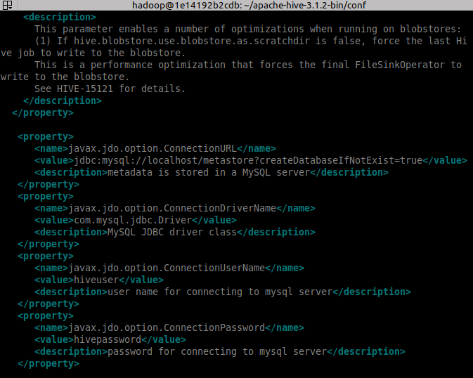

Remote Metastore
Moving further, another metastore configuration called Remote Metastore. In this mode, metastore runs on its own separate JVM, not in the Hive service JVM. If other processes want to communicate with the metastore server they can communicate using Thrift Network APIs. We can also have one more metastore servers in this case to provide more availability. This also brings better manageability/security because the database tier can be completely firewalled off. And the clients no longer need share database credentials with each Hiver user to access the metastore database.

Databases Supported by Hive
Hive supports 5 backend databases which are as follows:
- Derby
- MySQL
- MS SQL Server
- Oracle
- Postgres

